COMPUTER PROGAMMING

Note: You will learn C language until the finals no other sub topic other than this language, I will just put the simplified version of the learnings we learned from this subject.

Fundamentals in ©

This is the easiest to make but it has many things going on
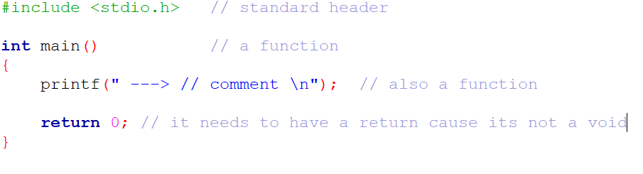
Lets break it down:
Standard header file
- It is used for the code you are using to work
An example was if you use a code from another library the code will print an error in your code
Other standard library

- Stdio.h means standard input && output , contains most of the code you learn in this word doc

- Stdlib.h means standard library, contains the memory allocation (only in the course I learned this but it’s a waste of time I you want to speed tun this © language)

- String.h contains some helpful code like copy the length of the array + other helpful code

- Math.h contains math operation + calculation

- Ctype.h contains the code to make the inputs user upper or lower case and more

- Stdbool.h contains the 0 && 1 means true or not code

printf(“Lets skip the use of function for now cause you need to learn it later”);

printf – print the letter || (means or) number inside “ ”

// ( 2 backslash ) means comment
/**/ an upgraded backslash means you can store more code inside the *.

syntax of c is simple its just ;
(lets make it pink so that you remember it better)

To note
- © is a case sensitive language that means you should not wright ,this is a variable , (it will give it an error)

You should write variable declaration like this

thisIsNumberOne;
this_is_number_one;

Variable || Arrays || constants || data types

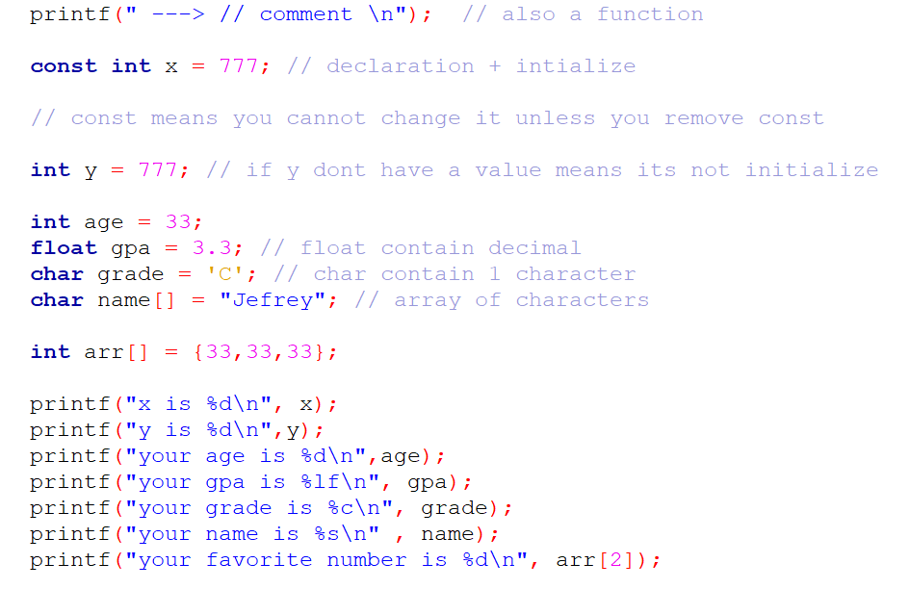

The difficult part of learning variables is by naming it

const int x = 777;

int && float && double && char is from data types
- They contain the number of bytes from char being 1 and the high is the double.

const is just constant

x is the variable that is being paired with the data types

data type + name + [] is just the array of © then you can declare the number of bytes from the {} or “ ” .

To access the output of the data type you need a format specifier

- Int %d
- Char %c if it’s a word %s
- Float %f you can manipulate the decimal value by putting 2f to show the 2 decimal place only.
- double %lf better version of float

char array[5] = {1,2,3}

the machine see it as 0,1,2 . why? It has a null character \0 at the end

to print it from the printf function you need
printf("your age is %d\n",age);
place the variable that you name from the initialized data type and don’t forget the , comma.

\n means new line

User input || arithmetic operators || logical operator
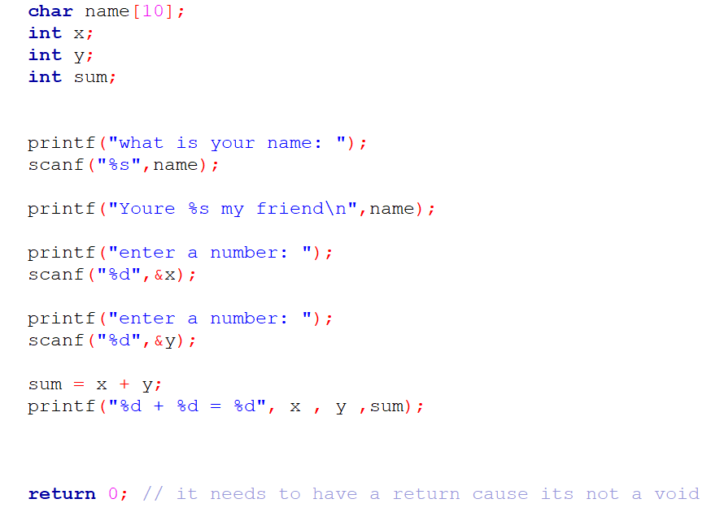
To get the users input you need scanf + the format specifier for the users input if it’s a character or a number and the ampersand (&) for the storage of this input then the name variable
- scanf(“%d”, &x);
Arithmetic operators
+ , - , * , / and % means modulus it counts remainder

++ means increasing the number by 1
--(decrement) means decreasing the number by 1

Logical operator is used in an if statement
&& and : both must be true
|| or : either one is true
!= not: reverse if its true its false
== equal

If statement has 2 parts the else if && else
If contains the condition in the (then you can put the logical operator inside here)

Else if executes if there is no true condition in the first statement

Else execute cause it’s the default option for the code or something else

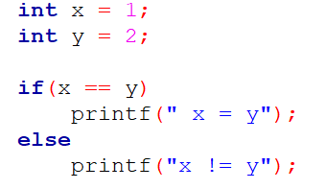
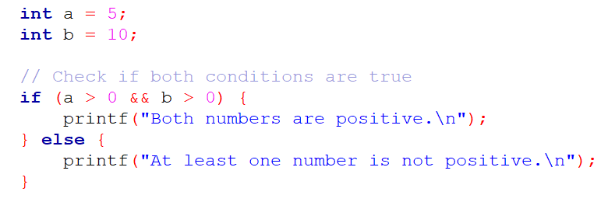
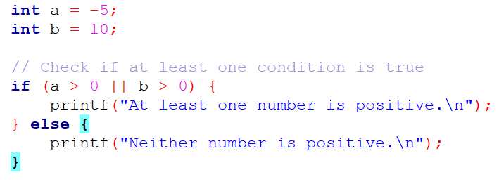
Loops && switch
For Loops contain an index + a condition + increment how long do you want to keep this loop
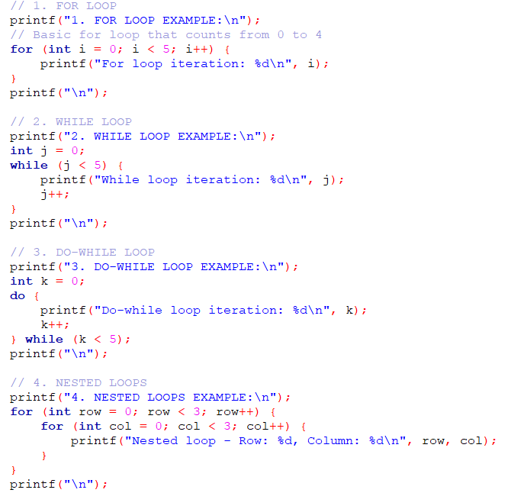
• For Loop: A traditional loop with initialization, condition, and increment.
- Syntax: for (initialization; condition; increment/decrement)
- Best used when you know the number of iterations in advance
• While Loop: Continues executing while a condition is true.
- Syntax: while (condition) { ... }
- Good when you don't know the exact number of iterations beforehand
• Do-While Loop: Similar to while loop, but guarantees at least one execution.
- Syntax: do { ... } while (condition);
- Useful when you want the code block to run at least once
• Nested Loops: Loops inside other loops
- Demonstrates how to create multi-dimensional iterations
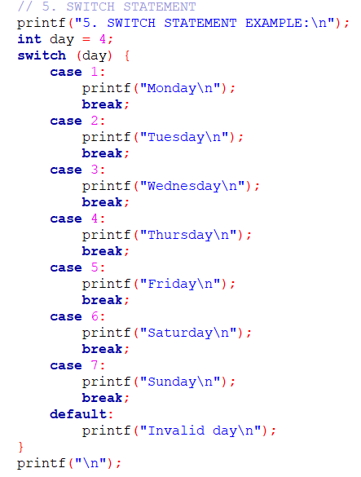
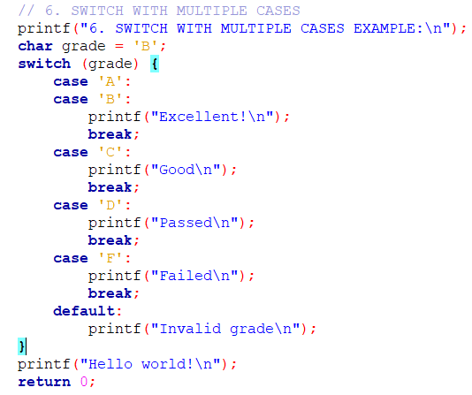
• Switch Statement: A multi-way decision structure
- Syntax: switch (expression) { case constant: ... break; }
- More readable alternative to multiple if-else statements
- Always include break to prevent fall-through
- default case handles any values not explicitly matched

FINALS TOPIC

POINTERS || FUNCTIONS

- Basic Functions
  - Simple functions that take arguments and return values
  - Declared with return type, name, and parameter list
  - Use return to send back a value

In other words its outside of the main function which makes the code
- Pointers and Pass by Reference
  - Pointers allow you to modify original variables
  - swap() function demonstrates how to exchange values
  - Use & to get address, * to dereference
  - Allows passing and modifying variables directly
- Dynamic Memory Allocation
  - malloc() allocates memory dynamically
  - Always free() dynamically allocated memory to prevent memory leaks
  - Useful for creating arrays or structures with runtime-determined size
- Function Pointers
  - Allows passing functions as arguments
  - Can store and call functions through pointers
  - Enables flexible, dynamic function calls
  - Syntax: return_type (*pointer_name)(param_types)
- Pointer to Pointer
  - Additional level of indirection
  - Useful for more complex memory manipulations
  - Can modify pointer's target dynamically
Important Pointer Rules:
- Always initialize pointers
- Check for NULL before dereferencing
- Free dynamically allocated memory
- Be careful with memory management to avoid leaks
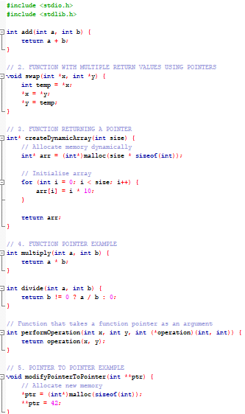
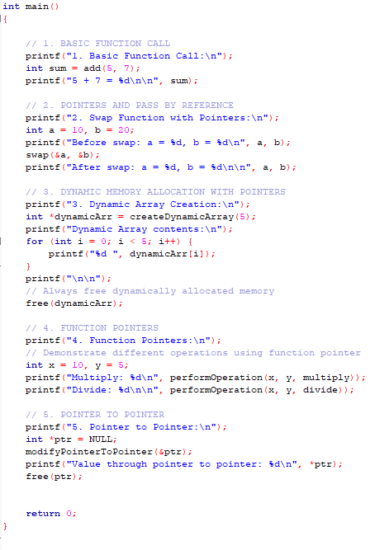

In short function is just outside of main and you use a function call inside the main to execute the function

You can use a function call from the if statement and inside the for loops and many more
if (function_call)

for(int I = 0; I < 5 ; I ++ )
{
function call here
}

For pointers you need an asterisk and p for the variable and never forget to specify the data types the int and char.

